DIRECTIONS OF THE CONFERENCE WORK:

1. Training of future specialists in the field of physical education and sports.
2. Professional and children-youth sports.
3. Medical and biological aspects of physical culture and sports.
4. Psychological and pedagogical aspects of physical culture and sports.
5. Modern trends in physical education of different age groups.
6. Management of physical culture and recreation activity.
7. Health and human life - the moral imperative of our time.

The materials of the conference will be printed before the beginning of its work in the scientific collection and published in the electronic repository of the National Technical University "Kharkiv Polytechnic Institute" (ISSN 2409-5982). The repository data is integrated into: the OpenAire project, the Bielefeld Academic Search Engine system, the search systems in the open archives of Ukraine and are indexed by Google Scholar.

The application should be created as follows:

APPLICATION
to participate in the I International Scientific and Practical Conference
«HEALTH OF NATION AND IMPROVEMENT OF PHYSICAL CULTURE AND SPORTS EDUCATION»
(if there are several authors, the form for each author is filled in one file application)

Author 1
Surname:________________________________
Name:__________________________________
Country,city:_____________________________
Place of work (full name of organization):_____
Position:________________________________
Academic degree, academic rank:____________
Contact telephones (mobile):_______________
E-mail:_________________________________
Participation in the conference: correspondence participation, full participation (emphasize your answer)
Speech with the report: yes, no (emphasize your answer)
Title of the report:________________________

Author 2, n ... (the same form as specified for the author 1)

The filename of the application must correspond to the name of the first author, with the addition of the letter Z and the symbol of the bottom underscore _ first. For example Z_Bilous.doc
Please, download the theses and applications in one email.
National Technical University «Kharkiv Polytechnic Institute»,
H.S. Skovoroda Kharkiv National Pedagogical University,
Kharkiv National Medical University,
National University of Pharmacy

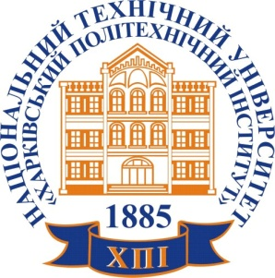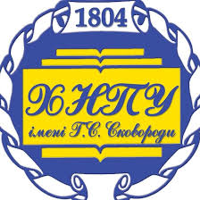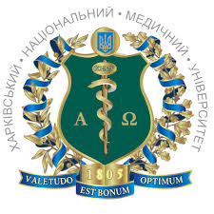

Department of Physical Education
National Technical University
«Kharkiv Polytechnic Institute»

INVITATION

to take part in the work of the

I International Scientific and Practical Conference

«HEALTH OF NATION AND IMPROVEMENT OF
PHYSICAL CULTURE AND SPORTS EDUCATION»

which will take place on October 3-4, 2019

Kharkiv
Basic dates of the conference:
till May 31, 2019 - submission of the materials of the report and applications;
till June 25, 2019 - announcement of the inclusion of the report in the program of work of the conference;
October 3-4, 2019 - the conference

Location of conference:
Ukraine, Kharkiv,
Alchevskikh street, 50-a,
Educational and Sports Complex «Polytechnic»,
Department of physical education, NTU «KhPI»

The travel and accommodation of the participants of the conference is carried out at the expense of the sending organization or at his/her own expense.

Contacts:
25199470@ukr.net – e-mail address for submission of materials of the report and applications;
+380963736909 – PhD Bilous Olesia, associate professor of the Department of Physical Education, NTU «KhPI»;
http://web.kpi.kharkov.ua/sport/uk/ –
e-mail address of the Department of Physical Education, NTU «KhPI».

The conference is dedicated to the 25th anniversary of the specialty "Physical Culture and Sport", which prepares specialists at the Department of Physical Education. For almost 70 years of existence, the Faculty of Physical Education has prepared winners, prizewinners and participants in the Olympic, Paralympic and Youth Olympic Games.
Now the Department of Physical Education seeks to expand contacts with specialists from different countries of the world for mutual exchange of experience in the preparation of athletes and improvement of physical education and sports education and public health! We know that you, your university is working on these issues and your opinion is very important to us! Therefore, we ask you to take part in the work of the conference!
For all foreign participants, the publication of the materials of the report is free. All foreign participants, whose papers will be accepted for publication, will receive an electronic version of the collection of works (in case of correspondence participation) or a collection of publications in print and a certificate (with full participation - a personal performance at the conference).
To participate in the conference it is necessary to send materials of the report and application for participation in the conference by May 31, 2019. Working languages ​​of the conference are English, Ukrainian, Russian. Participation in the conference is possible on-call and part-time. Works can be submitted in co-authorship. The materials of the report and application should be sent by e-mail to 25199470@ukr.net.
The editorial board reserves the right to reject materials which do not meet the requirements of design and scientific level.

Requirements for the design of the materials of the report:
Volume of abstracts 2-4 pages in the form of a computer file with the extension doc; font Times New Roman 12, interval 1.0; fields: to the left - 3 cm, to the right, to the top, to the bottom - 2 cm; paragraph 1.25. The last page should be filled at least 85%.
Compulsory structural elements of theses: title of the report, authors' surnames and initials, author's place of work, country, city, authors' e-mail addresses, abstract, keywords, introduction, purpose of research, results of the research and their discussion, conclusions. If necessary, it is possible to add a list of used sources of information (no more than 5 sources), designed in accordance with the APA standard. The references to the sources of information in the text should be made in square brackets.
An example of the presentation of the materials of the report:
SOME ASPECTS OF BALANCED DIET
AT THE PREPARATION OF HIGH QUALIFICATION SPORTSMEN
Bilous О.V.
National Technical University «Kharkiv Polytechnic Institute», Ukraine, Kharkiv, fazia@ukr.net

Abstract: the research devoted to …….
Keywords: ………..
Introduction..……………..
Purpose of research ……….
Results of the research and their discussion …….
Conclusions …………
List of sources of information ………….

The name of the file with the materials of the report should correspond to the surname of the first author. For example, Bilous.doc

